**“TOUCHING THE STARS:**

**IMMERSING IN CRYSTAL ENERGY”**

**A Sacred ‘Qawaq’ Journey in Peru, June 15 – 30, 2022**

**SACRED VALLEY - VILCABAMBA - MACHUPICCHU - AUSANGATE - CUSCO**

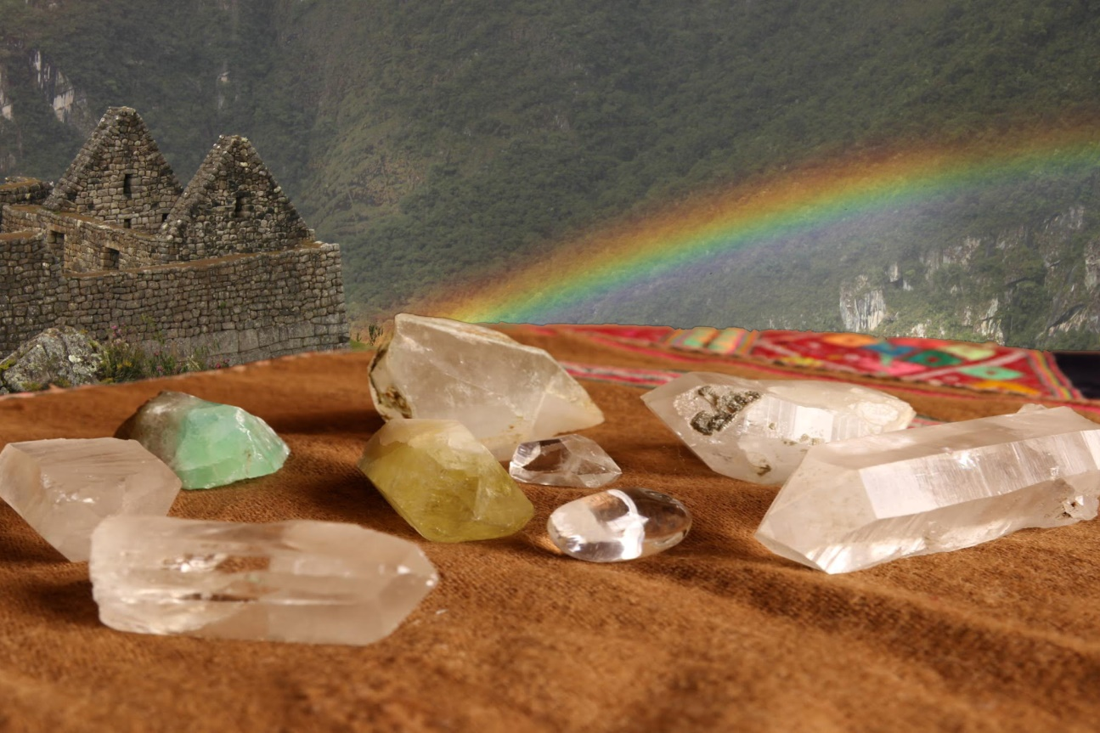

**Pictures by Luis Alejo.**

*“I have grown, I have healed, and my heart is more open than ever. I am so thankful for the opportunity I had to travel to Peru and soak up the magic.“ Miranda*

*\*\*\**

*“The trip was well organized and couldn’t have been better! I thank Luis and Saskia from the bottom of my heart!” Remco*

*\*\*\**

*“I was extremely happy with the paqo’s that came along with us and with Saskia and Luis as guides. Saskia’s enthusiasm added extra glow to the journey!” Isabelle*

*\*\*\**

**Are you up for a magical spiritual journey in 2022?**

**Do you want to open your third eye with brilliant starlight?**

The mountainous area in southern Peru around Cusco is a place where magic exists, and where ancient traditions meet modern life. Serendipity rules the days and intuition increases in miraculous ways. The people lovingly honour our Earth and Cosmos as sacred and very much alive, and being here strengthens your connection with these immensely powerful Nature energies.

We will journey through the Andean lands and do ceremonies and initiations at power places like world-famous Machu Picchu and at less visited ancient sacred sites. We will travel to the highest mountain in Cusco area, Ausangate, where we will camp during two nights in wintery temperatures and be awed by the Milky Way glistening right above us.

During this journey we will dive deeply into the Andean spiritual traditions and work with powerful forces of Nature. We will establish an intense relationship with diverse universal forces. This will greatly speed up the process of embodying our unique Destiny. We will be guided through this spiritual task with ceremonies and initiations by Andean paqos who are deeply steeped in the mystical traditions of the Andes.

This journey is the third journey inspired by Saskia Kuipers, who is a trained *pampa* *mesayoq* and a practicing medical doctor in the Netherlands. It will be held together with guide and interpreter Luis Alejo from Cusco, the owner of Serena Anchanchu School and Back2Nature, who facilitates spiritual journeys and is steeped in Peruvian mystical traditions.

Our group size will be limited to 12 people. The journey can be physically challenging as we will travel to altitudes of up 4600 meters (15000 feet), and the temperatures will vary from -5 to 30°C. The journey will be more easy and enjoyable if you are physically fit. Naturally we will always do our utmost for you to be comfortable under these extraordinary circumstances.

Saskia Kuipers: “*This journey is the third spiritual journey I am initiating, after having immersed myself for a long time in the Peruvian mystical traditions. My Peruvian mystical training started with don Juan**Ñunez del Prado (1999 to 2005), proceeded with five years of training with the Four Winds Society, and three years of training with Dennis Alejo and Q’ero paqos before they founded Serena Anchanchu school, where I culminated my training as a pampa mesayoq between 2011 and 2014.*

*Reconnection with Nature, Ayni (reciprocity), health and disease, have guided me in this long training process. I have been working as a medical doctor since 1990, since 1999 in clinical microbiology and infectious diseases. For me, the future holds the promise of a heart-based living and gentle ways of healing ourselves on all levels.*

*For years I dreamed of taking people on a journey around Peru. I love to empower people and to share the gifts of this beautiful wisdom held in the lands that have kept the Ancient Ways alive.*

**ITINERARY**

**Day 1: Cusco and on to Sacred Valley (2800m)**

Transfer from Cusco airport to our hotel in the Sacred Valley, where we will start our journey for easy acclimatization to the higher altitudes of the journey. In the afternoon we will meet the other group members so we can get to know each other and enjoy a nice dinner together.

**Day 2: Sacred Valley – Chinchero**

On this first full day of our journey we will meet the *Paqos* and set our intentions for the journey. The opening ceremony for our journey will take place at the historic site of Chinchero (altitude 3740m). Later, we will hike down to the village of Urquillos in the Sacred Valley via an old Inca path that follows the stream, giving plenty opportunities to spot hummingbirds and to breathe in the fresh scent of eucalyptus along the way.

**Day 3: Sacred Valley**

Today we will hike to Pumamarca along a path that gradually slopes up to the site. Walking along terraced countryside past the houses of local people we will get an idea of how life is in the community. At Pumamarca we will take time to relax and enjoy the views and the peaceful atmosphere. The *Paqos* will offer you a ritual in this tranquil place.

**Day 4: To Vilcabamba**

Today we will travel by private van together with the *Paqos* towards Yurac Rumi in Vilcabamba, a journey of over five hours. This place is mentioned in many books as the last refuge of the Inca’s, and in the surrounding mountains and valleys there seem to be many buildings and treasures waiting to be discovered. We will spend two nights in this area vibrant with history.

**Day 5: Vilcabamba**

In this area we will visit an enigmatic white rock called Yurac Rumi. In ancient times this site seems to have been an important ceremonial place. Yurac Rumi is a monumentally carved rock with shelves and steps, and its history is surrounded by mystery. We will tune in into its origins and functions. Here you will receive your first Crystal Mesa initiation. We will also explore other sites in this region.

**Day 6: Vilcabamba – Sacred Valley**

After enjoying a nice breakfast we will drive back towards the Sacred Valley. We will find a nice spot along the way where the *Paqos* will offer you the second Crystal Mesa initiation. We will arrive at our hotel in the late afternoon.

**Day 7: Ollantaytambo – Machu Picchu Town**

Today we visit the main temples of Ollantaytambo dedicated to different deities, and understand how important this arqueological site was for the Incas. Here you will receive your third Crystal Mesa initiation. This area was once the royal estate of Emperor Pachakuti who built the town and ceremonial center. In the afternoon we will head to the train station to travel to Machu Picchu town.

**Day 8: Machu Picchu**

A big highlight of this trip is the visit to the ‘lost city of the Incas’ Machu Picchu, located at an altitude of 2490 meters. Early in the morning we will head up to the ancient citadel that is one of the architectural and engineering marvels of the ancient world. Machu Picchu remains a mystery: the Spaniards never found it and the Incas left no record of it. We will meditate in a quiet spot to connect with the vibrant energy of this Crystal city, and you will receive your fourth Crystal Mesa initiation. In the afternoon we will have the return train to Ollantaytambo, and then proceed to Cusco.

**Day 9: Cusco (day off)**

This may be a day of rest and integration for you. However, Cuzco is full of heritage sites you may want to discover, like the Cathedral, the Qoricancha and its museum with temples for the Pleiades and Lighting, or the water temple at Tipon. Also, there is the interesting Witches Market at San Pedro.

**Day 10: Cusco - Mama Simona**

Not far from Cuzco lies the 4341m-high mountain called Mama Simona, where a powerful priestess lies buried. The energy of this ñusta or Inca princess is connected to the ancestors and to hummingbird’s nectar. Today we will walk for two hours to the summit where we can enjoy panoramic views of many apu’s. Here the *paqo’s* will perform a ceremony to transmit to you the fifth Crystal initiation.

**Day 11: Cusco area**

Above Cusco lies impressive Sacsayhuaman, an ancient place resembling the head of a puma that hosts the yearly Inti Raymi festivities. Today we will wonder at the overwhelming megalithic structures of this Temple of Lightning. We will continue to walk toother ancient sites close by, accompanied by the *Paqos*. Here you will receive your sixth Crystal Mesa initiation.

**Day 12: Cusco - Ausangate**

Early morning we will drive towards Pacchanta village (altitude 4200m). This trip will give us views of the spectacular Andean landscapes when the skies are clear. After resting at Pacchanta, we will hike 9 km (optional: rent a horse) over a gradually sloping mountain path that crosses agricultural fields with herds of alpacas. We will camp at 4600m and awe at majestic Apu Ausangate, the highest apu in Cusco also known as “the Lord of Manifestation”. In the evening we will share a fire ceremony under the stars. Here, in the frosty nights your jacket, thermal underwear, warm gear, gloves and hat are obligatory.

**Day 13: Ausangate**

After breakfast we will walk towards the sacred lagoons of Ausangate and marvel at the glistening white peaks that surround us. In this harsh and utterly beautiful environment we will enjoy another intense ceremony with the *Paqos*. Here you will receive your seventh Crystal Mesa initiation.

**Day 14: Ausangate - Cusco**

After breakfast, our tents and all other camping equipment will be packed on the horses. Then we will descend to the village of Pacchanta by foot (or horse). From Pacchanta we will travel back to Cusco where we will stay in a comfortable hotel in the old part of the city and enjoy a nice shower and a good rest.

**Day 15: Cusco - Farewell Dinner**

In the morning we will wrap-up our experiences together with the *Paqos* in a beautiful spot near Cusco, after which there is time to gently ease back into a more worldly state-of-mind. In the evening we will enjoy our farewell dinner in Cuzco to celebrate the intense journey we shared together.

**Day 16: Cusco - Lima - back home (or maybe not)**

For those who want to stay a bit longer to assimilate the journey we can arrange for you to stay in Cusco. Others will journey to Lima for the return flight back to the home country.

**\*\*\*\*\*\*\***

**The Sacred Journey team consists of Saskia Kuipers, Luis Alejo and *Paqos.***

**For information on the trip and the spiritual work please contact:**  
 Saskia Kuipers MD PhD, the Netherlands – inspirator (the Netherlands)

[kuipers.saskia@gmail.com](mailto:kuipers.saskia@gmail.com) /

**Phone**: +31 650671230.

**Skype**: saskia.kuipers21

**For logistical information and bookings please contact:**  
 Luis Alejo, Peru - tour guide (Peru)

[luis@back2nature.com.pe](mailto:luis@back2nature.com.pe) /

**Peru Phone:** +51 84 984001975

**Skype**: luisqero.

**Note:** Although carefully anchored in an energetic “template” as well as in detailed practical advance planning, this itinerary remains “subject to reality.” It is the nature of pilgrimage and apprenticeship that some things may change at the last minute. In our experience, the few changes that occurred on our previous journeys often opened the door to unforeseen (and usually wonderful) opportunities. Thank you in advance for your flexibility and willingness to adapt, to take advantage of the ever-changing possibilities inherent in a fluid universe.

**\*\*\*\*\*\*\***